ADDENDUM TO RFP DOCUMENTS

REQUEST FOR PROPOSAL: 15-RFP-FCL-2021 Lawn Maintenance

ADDENDUM No. 1 DATE: 5/3/21

To All Potential Bidders:

This addendum is issued to modify the previously issued bid documents and/or given for informational purposes, and is hereby made a part of the bid documents. Please attach this addendum to the documents in your possession.

Subject line: Practice Fields Pg. #9 13

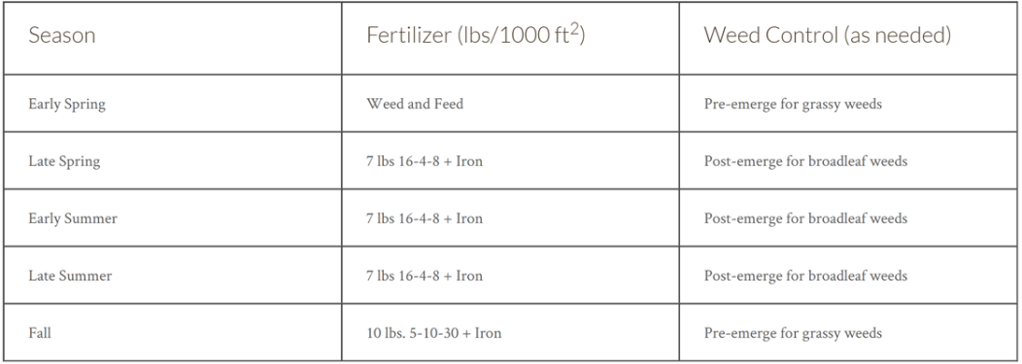***Clarification:*** Fertilizer and Weed Control Table

**ATTACHMENT “F”** 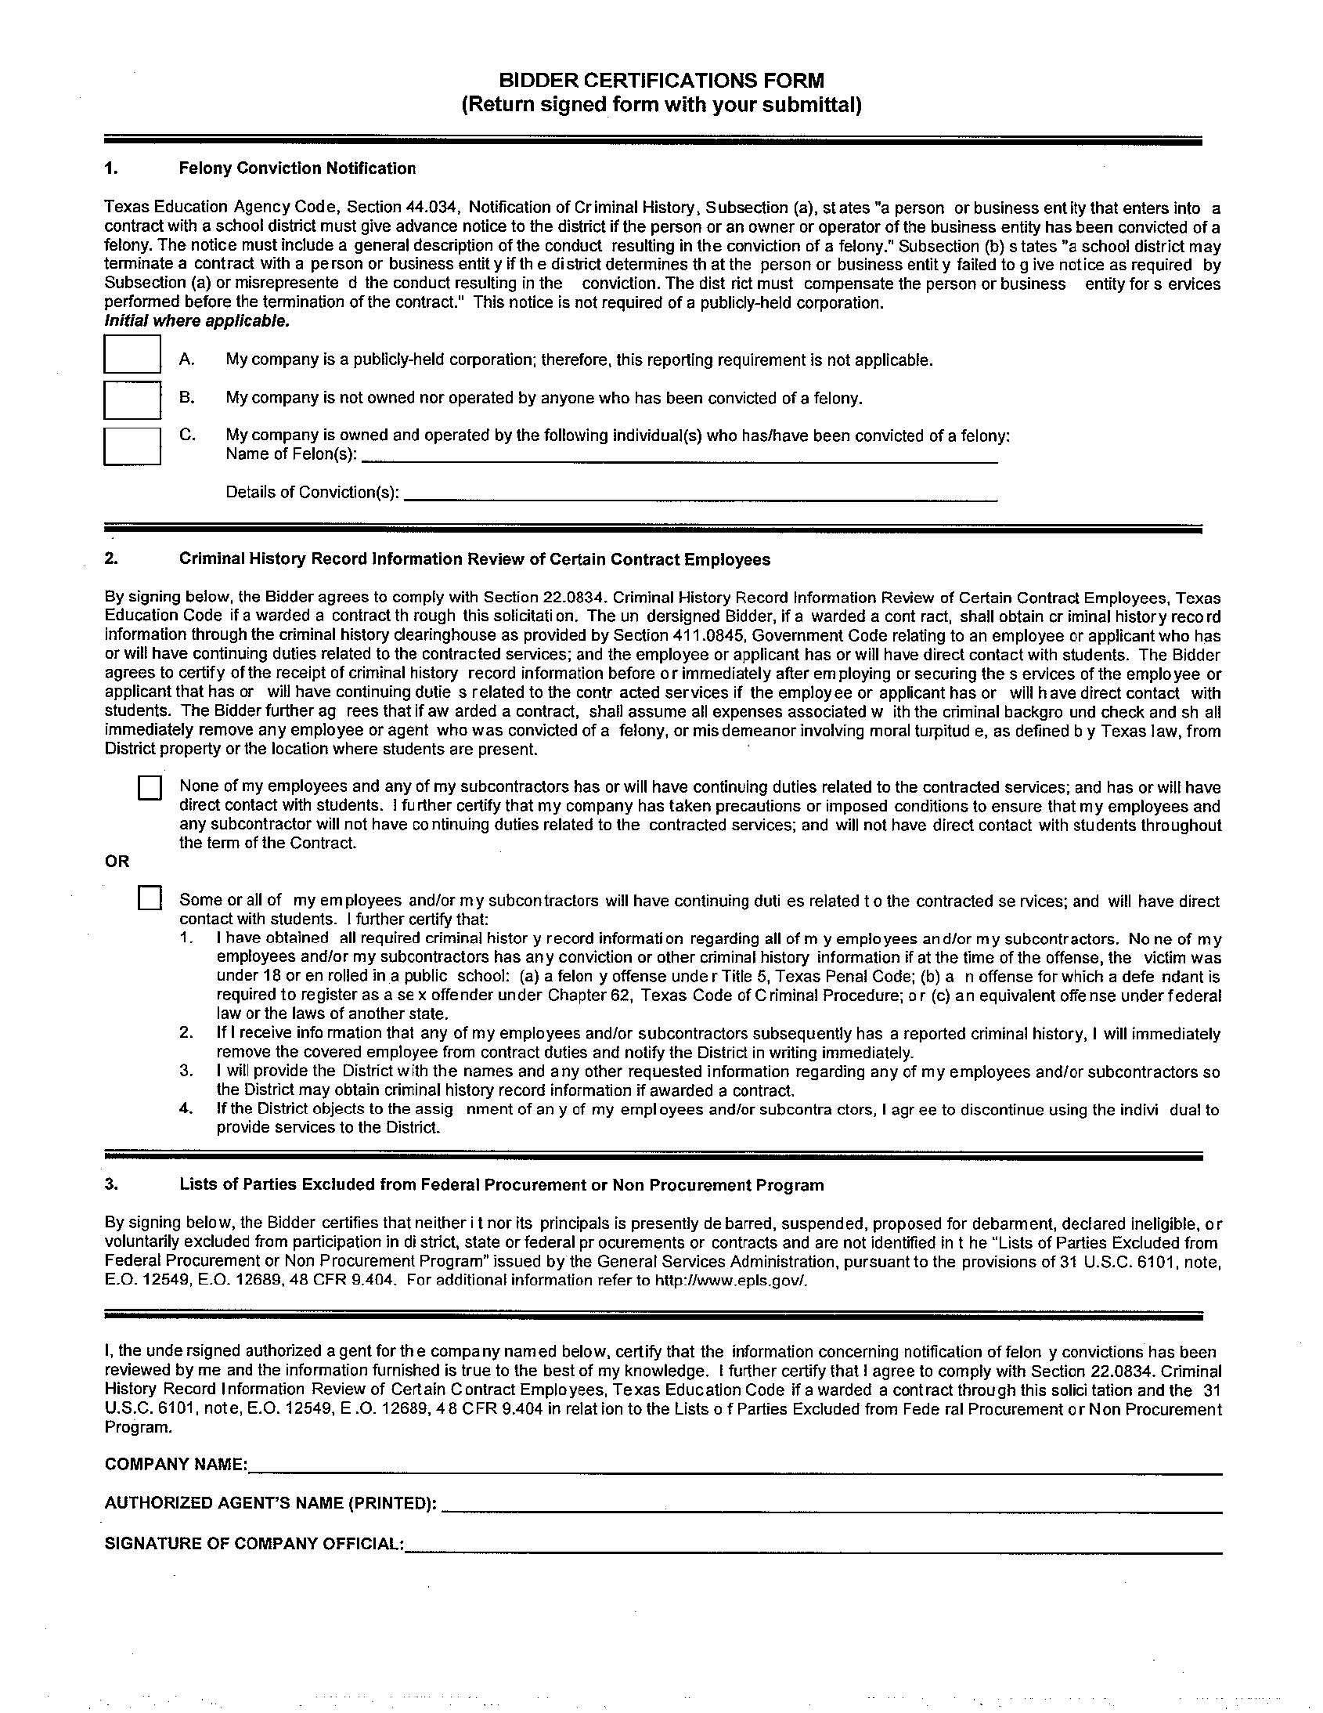



Point of Contact: