2020-2021
BACK TO SCHOOL SUPPLY LIST IDEA INGRAM HILLS
Pre-Kinder- 3rd grade

Item | Quantity | Picture | Approximate  Price
Crayola Crayons | 1 Pack of 24 Crayons |  | $2.00
Baby Wipes | 1 Packs | 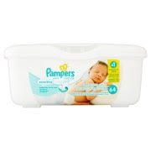 | $1.00
Kleenex | 2 Boxes | 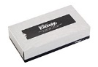 | $2.00
Plastic Folder with pockets  (1 blue, 2 red, 2 green and 1 yellow) | 6 Folders | 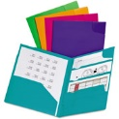 | $5.00
Ticonderoga Pencils | 1 Packs of 12 Pencils | 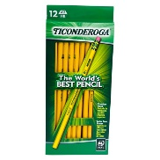 | $3.00
Bounty Paper Towels | 1 Rolls of Paper Towel | 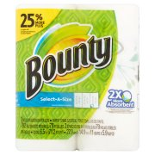 | $2.00
Total |  |  | $15.00

Reminders:
- Please do not write names on the items. All supplies will be shared as community supplies.
- Please only purchase plastic folders. If you cannot find these specific colors, please purchase plastic folders of any color.
- Please do not send your scholar with Sharpies. These are not allowed at school. Thank you!

2020-2021
BACK TO SCHOOL SUPPLY LIST IDEA INGRAM HILLS
6th-8th

Item | Quantity | Picture | Approximate  Price
Post It Notes | 1 Pack of  3x3 colorful pack Post-it Notes | 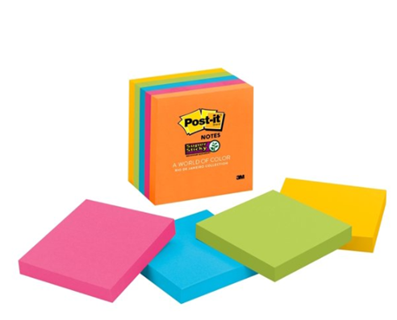 | $6.00
Index Cards | 2 packs of 3x5 ruled index cards (100 count) | 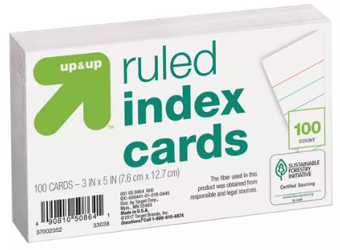 | $2.00
Kleenex | 2 Boxes |  | $2.00
Ticonderoga Pencils | 1 Pack of 12 Pencils |  | $3.00
Bounty Paper Towels | 1 Roll of Paper Towel |  | $2.00
Total |  |  | $15.00

Reminders:
- Please do not write names on the items. All supplies will be shared as community supplies.
- Please do not send your scholar with Sharpies. These are not allowed at school. Thank you!

