IDEA PUBLIC SCHOOLS
REQUEST FOR PROPOSALS
FOR HYDROPONIC FREIGHT CONTAINER FARMING EQUIPMENT FOR THE CHILD NUTRITION PROGRAM

Proposals for this Solicitation are due no later than January 13th, 2020 at 9am.

TABLE OF CONTENTS

No Submittal Response Form ………………………………………………………………………………………………………. 3

Section 1: Administration ……………………………………………………………………………………………………………..4

Section 2: Scope of Work ………………………………………………………………………………………………………………6

Section 3: Pricing …………………………………………………………………………………………………………………………11

Section 4: Evaluation ……………………………………………………………………………………………………………….….12

Section 5: Award of Contract ………………………………………………………………………………………………………14

Vendor Acknowledgement Form …………………………………………………………………………………………….….15

Proposal Submission Checklist ………………………………………………………………………………………………….…16

Reference Sheet…………………... …………………………………………………………………………………………………… 17

Certification of Respondent ... …………………………………………………………………………………………………… 18

Certification Regarding Drug Free Workplace………………………………………………………………………………19

Equal Opportunity and Nondiscrimination ………………………………………………………………………………….20

Proposal Questionnaire…………………………. …………………………………………………………….…………………….21

Clean Air & Water …………………………………. …………………………………………………………….…………………….22

Bidder Certification Forms ……………………………………………………………………………………………………….….24

Certification Regarding Lobbying Procurement…………………………………………………………………………….25

Clarification Regarding Debarment, Suspension, Ineligibility, and Voluntary Exclusion ‐ Lower
Tier Covered Transactions ……………………………………………………………………………………………………………26

Campus Locations …………………………………………………………………………………………………………………….….27

NO SUBMITTAL RESPONSE FORM

If your company will not be submitting a proposal in response to this Request for Proposals (RFP), please complete form and return, prior to the RFP due date established within, to:

IDEA Public Schools
Child Nutrition Program
Attn: Hernan Colmenero, CNP Farm Manager
2115 W. Pike Blvd.
Weslaco, TX 78596

This information will assist Procurement Services in the preparation of future RFPs.

RFP #: 03‐RFP‐CNP‐FARM Title: HYDROPONIC FREIGHT CONTAINER FARMING EQUIPMENT AND PROFESSIONAL SERVICES

Company Name: ____________________________________________________________________________

Contact: ___________________________________________________________________________________________

Address: ___________________________________________________________________________________________

Telephone: ________________________________ Fax: _________________________________

Email: _____________________________________________________________________________________________

Please check reason for a “no submittal”

______ Specifications “too tight”, geared toward one brand or manufacturer (explain below)

______ Insufficient time to respond

______ Specifications unclear (explain below)

______ We do not offer this product/service or an equivalent

______ Our product schedule does not permit us to perform

______ Unable to meet specifications

______ Unable to hold prices respondent throughout the term of the contract period

______ Unable to meet insurance requirements

______ Other: ______________________________________________________________________________________

Print Name: _________________________________________________________________________________________

Signature: __________________________________ Date: _______________________

If submitting this form, only this form needs to be returned. It is not necessary to return the entire RFP package.

REQUEST FOR PROPOSALS

IDEA PUBLIC SCHOOLS

HYDROPONIC FREIGHT CONTAINER FARMING EQUIPMENT AND PROFESSIONAL SERVICES, RFP # 03‐RFP‐CNP‐FARM

Due Date/Time: January 13, 2020 at 9:00 a.m.

Sealed proposals must be mailed or hand carried to: 2115 W. Pike, Weslaco, TX 78596, Attention: Hernan Colmenero, Farm Manager by the due date and time as indicated above. All proposals shall be submitted in sealed mailing package and clearly marked with the proposal number, title, proposal opening date and time. The delivery of proposals prior to the specified date and time is solely the responsibility of the proposer. Proposals received after the due date and time will not be considered.

If you have any questions in regards to this RFP process, please contact Katelyn Zellner, CNP Farm Supervisor, at (210) 815‐0392.

Section 1: Administration

1.1 Introduction

IDEA Public Schools (herein after referred to as “IDEA” or the “District”) is a growing network of tuition‐free Pre-K- 12 public charter schools serving more than 36,000 students in 61 schools throughout the Rio Grande Valley, Austin, and San Antonio. IDEA is a 501(c)(3) non‐profit organization. Funding for the District operations and programs are provided through fundraising, philanthropic grants, state and federal funding.

The purpose of this RFP is to secure a hydroponic system used to grow vegetables that includes all of the equipment and any necessary software needed to grow leafy green vegetables, herbs, flowers, and fruits for the school cafeteria effectively. We require a system that has the capability for continuous crop growth and harvesting at a sufficient rate as to feed a cafeteria of about 2,000 students on a daily basis. We also require data analysis that lead to sound decision making, from a food safety perspective. We want a growing system that is not only productive but serves as an educational space for teachers and students on our campuses.

We envision this system to have distinct “Front End” and “Back End” capabilities. Generally speaking, “Back End” functions would include computer automation and electronic data processing of tasks and monitoring of information necessary for the operation of a hydroponic system. It should also have the capability to alert the operator if something is keeping the system from performing as it should. “Front End” functions would include all activities that allow the growth of mature edible crops such as starting of seeds in plugs, transplanting capabilities, space and nutrient system for the maturation of plants, and finally a space for the harvesting of the produce that is compliant with GAP Harmonized Food Safety standards. The District is cognizant of our responsibility to be good stewards of all federal funds received, and therefore cannot purchase a permanent structure. We will select a provider, based on the criteria noted herein, that is capable of working with us in providing the equipment, the services and the accommodations necessary to establish a hydroponic growing system while minimizing overall costs.

No advance payments will be made to the vendor receiving the proposal award. Payment will be made after the services have been received. Payment will be issued upon review and approval of invoice given that there are no discrepancies or disputes within IDEA Public School’s 30‐day net policy.

1.2 Time Schedule

The District will attempt to use the time schedule as indicated below. The below dates are subject to change.

ACTIVITY SCHEDULED DATE
1 | RFP Issued & Public Announcement | January 5, 2020
2 | Closing Date for Receipt of Questions | January 12, 2020
3 | Closing Date for Receipt of Proposals | January 13, 2020
4 | Mandatory Requirements Evaluation | January 15, 2020
5 | Proposal Evaluations | January 15, 2020
6 | Contractor Selection/Award Notification | January 16, 2020
7 | Contract Tentative Award Date | January 20, 2020
8 | Contract Tentative Start Date | January 20, 2020
9 | Equipment Delivered to IDEA Quest campus | February 3, 2020
10 | Payment is Sent to Vendor | Before March 3, 2020

Section 2: Scope of Services

Product Requirements – The following description of requirements should be considered the minimum functionality required. Respondents should submit a detailed description of all the possible functions of the equipment and software, even if they exceed the following descriptions.

2.1 General Equipment Requirements & Specification

Technical Architecture
Describe the technical architecture of the proposed system, including the recommended hardware and software environment for the application. Include such information as growing rack size, growing process and procedures, lighting equipment and functionality, nutrient solution descriptions, water tank maintenance, and general maintenance of the equipment/units. A high‐level illustration of the work-flow schema for the proposed system should also be provided.

Note: Respondent’s proposal must offer the option and the minimum requirements for IDEA to adjust the components as necessary to accommodate for specific crops.

Security
Describe security features of the proposed system to mitigate theft and/or vandalism to the equipment.

Application Customization
Describe options and tools for tailoring the applications to meet IDEA’s needs (referenced in sections 2.2 – 2.7) including configuration, custom reports and screen development or modification. Describe how your software will track data necessary to be compliant with USDA GAP Harmonized Food Safety standards. Identify other districts in Texas using your system complete with production amounts. (If this information was included in a previous section, reference here.) Describe your policy on software releases including frequency, year‐end updates, requirements for system software upgrades, and process for determining what enhancements are included in which release. Provide any costs required to obtain the updates.

Interface Capabilities
Describe the proposed software’s methods for interfacing with other information systems and limitations such as the Microsoft Office 365 suite (Sharepoint, Onedrive, Onenote, Excel, Word, etc.).

Hardware Specifications
Provide the recommended spacing requirements for proper functionality of the said equipment to operate as a system and any other recommended hardware peripheral. Detail the number of people required to operate, the number of labor hours per week, total production capacity, energy consumption, water consumption, fertilizer and other consumables consumption rate, and finally the total cost to operate.

Server Software Specifications
Provide the recommended system software configuration required to operate the proposed software. Specifications should include product name and version/service pack requirements for:
- Operating system
- Database management system
- Reporting tools
- Networking software
- Any other required or recommended server software

2.2 General Hydroponic Equipment Requirements & Specifications

Hydroponic Equipment Hardware Specifications
Provide both the recommended configuration and the minimum supported configuration for proposed hardware to:
- Enable fresh food production under any external weather conditions
- Climate control system to regulate temperature, ph levels, nutrient levels, and humidity
- Allow for the most efficient use of space
- Allow for the ability to scale up or scale down as needed
- Grow a wide variety of leafy greens, herbs, fruits and flowers
- Be practical to be installed in or near a school cafeteria building
- Provide the proper light wavelengths for optimum plant growth
- Produce enough vegetables to outweigh the equipment costs in a short amount of time
- Be able to recycle the water to minimize input and maintain a clean environment
- Be intuitive enough to allow students with no prior farming experience to operate with minimal training and oversight

Hydroponic Equipment Software Specifications
Provide the recommended software configuration (if applicable) to support the proposed solution for hardware to be used at maximum growing capacity. Also, identify any other software products or versions supported. Specifications should include product name(s) and version(s)/service(s) packs supported for the following as applicable:
- Ability to monitor and regulate temperature, ph levels, CO2 levels, and humidity
- Ability to track the sensors from remote location
- Ability to inform the operator when a component is in need of attention
- Ability to track multiple systems from one interface
- Ability to track the same system form multiple interfaces
- Offer option to export to CSV, XML, or Excel file of data
The system must communicate daily with the operator in a way that is seamless to the end user. The equipment must be able to operate if network connectivity is lost at any time. Appropriate hardware should be identified to provide uninterrupted service in the event of a network outage.

2.3 General Growing/Harvesting Requirements & Specifications
Proposals should provide a detailed workflow of the hydroponic growing and harvesting system. Proposals should also address the relationship between the physical growing and the software interface. Respondent shall clearly address how:

- System is set up initially to meet the aforementioned specifications in section 2.2
- Seeds are started to begin growing process
- Seedlings are transplanted (if applicable) to allow for full maturity
- Crops are tended to
- Crops are fertilized and watered
- Succession plantings are scheduled to maximize harvest in the space available
- Harvest is performed to meet the USDA GAP Harmonized Food Safety standards
- Data is uploaded and manipulated to meet our needs
- Equipment maintenance and cleaning is performed (growing racks/towers/shelves, lighting, irrigation lines and tanks, coolant [if applicable] etc.)

2.4 Additional Services

Please indicate a comprehensive list and detailed description with available reports of all additional modules that your company offers which can integrate with the aforementioned software specifications. In addition to the list include costs (software, hardware, training, support, etc.) required to implement each of the modules.

Examples of such modules that would be of interest to the District include the following.
- The ability to move the system if necessary
- Continued education to refine growing practices
- Allow for the delivery of supplies on a recurring basis
- Automatic climate control adjustment

2.5 Training Requirements

The District recognizes the importance of training as the single most important factor for a successful and effective system implementation.
- Describe your company’s training program to include all options and associated costs.
- Provide the sufficient levels of training necessary to operate system at its maximum capacity
- The scope of the system training is to include all functions for set‐up, system administration, installation and on‐going operation of the system.
- Training is to be done by a qualified instructor(s) and shall provide for a predominantly “hands‐on” type of instruction. Copies of comprehensive reference materials shall be provided by the Contractor to cover the contents of the training session(s) that will become part of IDEA Public Schools documentation for the system.
- Provide recommended seed varieties, consumables, and tools for optimum growth and harvest.

2.6 Administration and Staff Qualifications

Describe the qualifications and experience of the partners, managers, and other professional staff that will provide the services to IDEA Public Schools. Respondent shall ensure that staff has all required licenses, certifications, and training appropriate for such persons’ role and function within the firm. Documentation that describes job qualifications and experience will be acceptable. Provide the name and contact information for the point of contact for these services.

2.7 Insurance Coverage

Adequate insurance coverage must be presented in the form of certificate of insurance.

Section 3: Pricing

3.1 Proposal Pricing

The submittal shall include the Respondent’s proposed pricing. It is expected that all Respondents offer educational discounted rates. Please itemize all discounts on the quote. IDEA reserves the right to accept or reject proposed pricing.

All fees as quoted shall be held firm for the initial contractual period of one calendar year. Fees shall be clearly summarized in submission, without question whatsoever.

Please itemize the proposed fees of each component of your offered products and services. The requested products and services should include all hardware, software, installation, upgrades, technical services, training, and support related to the hydroponic growing system. Any fees for additional products and /or services offered must be clearly indicated.

The following information should be included in the fee proposal:
- Item or service
- Is item or service required or optional for operation of system?
- Which module does item function with
- Unit cost
- Number needed for proposed configuration

Total fees

Please indicate estimated fees, if any, for acquiring/ licensing updated versions of software. Please indicate which, if any, essential hardware components may be purchased separately and provided by the school district and therefore excluded from the vendor’s cost proposal.

Proposal shall also include annual maintenance/support fees and shall indicate whether or not these fees are fixed and, if so, for what period. Detailed analysis of all fees, itemized by software, hardware, maintenance/support, by location, by module.

Section 4: Evaluation

4.1 Introduction

The evaluation of proposals shall be conducted comprehensively, fairly, and impartially. Structural, quantitative scoring techniques will be utilized to maximize the objectivity of the evaluation.

4.2 Proposal Evaluation Committee

An evaluation committee will be selected from IDEA to perform all evaluation requirements. The committee will be composed of individuals with experience in, knowledge of, and program responsibility for the requirements identified in the RFP. IDEA reserves the right to request information from the respondents to clarify the proposals submitted.

4.3 Evaluation Phases

Evaluation phases will be conducted as follows:

Phase 1....Evaluation of Mandatory Requirements
Phase 2....Technical Proposal Evaluation
Phase 3....Price Proposal Evaluation
Phase 4....Recommendation for Contract Award

Phase – 1 Evaluation of Mandatory Requirements

The evaluation of the mandatory requirements, as listed below, shall be based upon a “Pass/ No Pass” basis. The purpose of this phase is to determine whether a Respondent’s proposal is sufficiently responsible and responsive to RFP requirements to permit a complete evaluation, i.e. responsible in terms of “Does the respondent have the capability to perform fully the Scope of Services requirements”; and, “Were proposal documents, as identified below, received by IDEA and do they contain the required information?” Failure to meet any mandatory requirement may be grounds for deeming the proposal non‐responsible, non‐responsive or both and disqualification (“No Pass”) thereof.

Proposal Mandatory Requirements
Proposal Cover Letter on corporate letterhead
Vendor Acknowledgement Form
Proposal Submission Checklist with required documents
Technical Proposal
Price Proposal
State of Texas Compliance Documents

Phase 2 – Technical Proposal Evaluation

Evaluation of respondent’s technical proposal shall be conducted using the technical proposal categories and the value weight percentages identified in paragraph 4.4 and the evaluation scoring system identified in paragraph 4.5.

Phase 3 – Price Proposal Evaluation

Evaluation of the price proposal shall be conducted using the price proposal category and the value weight percentages identified in paragraph 4.4 and the evaluation scoring system identified in paragraph 4.5.

Phase ‐ 4 Recommendation for Contract Award

Evaluation Committee shall prepare a report summarizing proposal evaluation findings/rankings and provide recommendation for award of contract.

4.4 Evaluation Categories and Value Weight Percentages

Mandatory Requirements Pass/No Pass

Technical Proposal
Compliance with Specifications ………………………………………….……............... 20%
Method of Approach to the Scope of Services........................................... 20% Personnel Organization and Staffing.......................................................... 10%
Additional Value Added Services …………………………………………………………….10%
References and Past Performance ………………………………………………………….10%

Price Proposal............................................................................................. 30%

TOTAL .................. 100%

4.5 Evaluation Scoring System

The maximum number of points available for scoring is one hundred (100) per proposal. The proposal receiving the highest number of points is considered statistically the best proposal and the best value to IDEA; and, will be recommended for award of contract, unless otherwise determined and justified by the evaluation committee.

The evaluation categories are assigned a value weight percentage, as determined by IDEA, totaling 100%. Each category will be rated and points awarded based on the percentage weight of each evaluation criteria. Maximum score (the best rating) cannot exceed the percentage number for the evaluation criteria. A group score agreed to by the evaluation committee for each evaluation criteria. The respondent’s total score (see note below) will be determined by totaling each committee score for each individual evaluation criteria.

Note: In determining the total score, the respondent’s price proposal with the lowest price will receive the highest available rating allocated to price. Each proposal that has a higher price than the lowest will have a lower rating for price. The points allocated to higher‐priced proposals will be equal to the lowest proposal price multiplied by the maximum points available for price, divided by the higher proposal price.

Section 5: Award of Contract

Award of contract shall be made to the most responsible and responsive respondent whose proposal is determined by the Evaluation Committee to provide the best value to IDEA, considering all evaluation reviews and results.

5.1 Contract Award Notification

The notice of award, if any, resulting from this solicitation shall be posted on the IDEA Public Schools website. This will serve as the official notification to all Respondents. In addition, the Issuing Officer will inform the successful respondent of contract award selection by an official “notice of award” letter. At its discretion and as a courtesy to the Respondents the Issuing Officer may issue a “Notice of Posting of Award” to the unsuccessful respondents. However, a delay in issuing the notice or the inadvertent omission of such courtesy notice will not extend the protest filing time.

5.2 Contract Award Debriefing

A debriefing may be held after contract award at the request of any Respondent for the purpose of receiving specific information concerning the evaluation. The discussion will be based primarily on the technical and business and cost evaluations of the Respondent's proposal. A debriefing is not the forum to challenge the RFP specifications or requirements.

5.3 Lobbying

Selection committee members (except the Procurement Services representative) are not to be contacted prior to the IDEA’s decision to approve or reject the final recommendation. At the discretion of the District, failure to comply with this requirement will be grounds for disqualification.

Specifically, this NO‐CONTACT PERIOD shall commence on the initial date of the advertisement for Request for Proposal and continue through and include the date IDEA makes its determination to approve or reject the final recommendations. Failure to meet any of these requirements may disqualify your organization from consideration.

VENDOR ACKNOWLEDGEMENT FORM

The respondent hereby certifies, by submission and signature of this proposal that the respondent complies fully with this RFP. In addition, the representative below is duly authorized to sign this proposal on behalf of the respondent, company, or corporation and fully understands that by virtue of executing and returning this Vendor Acknowledgement Form represents complete and unconditional acceptance of the requirements, terms and conditions of this RFP and all appendices and any addendums released hereto.

Respondent(s) must complete the following Vendor Acknowledgement Form and include it as a cover sheet for proposals submitted in response to this RFP.

HYDROPONIC FREIGHT CONTAINER FARMING EQUIPMENT AND PROFESSIONAL SERVICES

A Proposal Submitted in Response to IDEA Public Schools RFP # 03‐RFP‐CNP‐FARM

The proposer hereby agrees to provide the services and/or items specified in the RFP at the prices quoted pursuant to the requirements of this document.
Authorized Signature |  | Name & Title
Respondent Name |  | Federal I.D. #
Mailing Address
City |  | State | Zip
Telephone | Fax | E‐Mail Address
Date of Proposal Submission |  | Contact Person, Number

PROPOSAL SUBMISSION CHECKLIST
(Please check (✓) the following)

- Completed: Vendor Acknowledgement Form

- Completed: Proposal Submission Checklist

- Completed: Technical Proposal

- Completed: Reference Sheet

- Completed: Proof of Insurance or Bonding

- Completed: Certification of Respondent

- Completed: Certification Regarding Drug‐Free Workplace

- Completed: Conflict of Interest

- Completed: Equal Opportunity and Nondiscrimination

- Completed: Proposal Questionnaire

- Completed: Clean Air & Water Act

- Completed: Bidders Certification Form

- Completed: Certification Regarding Lobbying

- Completed: Certification Regarding Debarment

REFERENCE SHEET

Note: Respondent must submit at least three (3) responsive business references. (References from past and/or present contract demonstrating Company’s qualifications, experience, and performance.)

Reference # 1

Organization Name: _________________________________ Telephone #: ________________

Contact Name: __________________________________ Email Address: ____________________

Address: _______________________________________ Student Population: ________________

Scope of Work Provided: ______________________________________________________________

___________________________________________________________________________________

___________________________________________________________________________________

Reference # 2

Organization Name: _________________________________ Telephone #: ________________

Contact Name: __________________________________ Email Address: ____________________

Address: _______________________________________ Student Population: ________________

Scope of Work Provided: ______________________________________________________________

___________________________________________________________________________________

___________________________________________________________________________________

Reference # 3

Organization Name: _________________________________ Telephone #: ________________

Contact Name: __________________________________ Email Address: ____________________

Address: _______________________________________ Student Population: ________________

Scope of Work Provided: ______________________________________________________________

___________________________________________________________________________________

___________________________________________________________________________________

CERTIFICATION OF RESPONDENT

I, the undersigned, submit this quote/bid and have read the specification, which are a part of this solicitation. My signature also certifies that I am authorized to submit this proposal. Sign as a representative for the firm, ad carry out services solicited in this RFP:

Signature of Authorized Agent: | ________________________________________
Printed Name and Title of Agent: | ________________________________________
Name of Firm: | ________________________________________
Address: | ________________________________________
Telephone Number: | ________________________________________
Fax Number: | ________________________________________
Contact Person: | ________________________________________
Email Address (if applicable): | ________________________________________
Web Site Address (if applicable): | ________________________________________

CERTIFICATION REGARDING DRUG‐FREE WORKPLACE

This certification is required by the Federal Regulations Implementing Sections 5151‐5160 of the Drug‐Free Workplace Act, 41 U.S.C. 701, for the Department of Agriculture (7 CFR Part 3017), Department of Labor (29 CFR Part 98), Department of Education (34 CFR Parts 85, 668 and 682), Department of Health and Human Services (45 CFR Part 76).
The undersigned subcontractor certifies it will provide a drug‐free workplace by:
- Publishing a policy statement notifying employees that the unlawful manufacture, distribution, dispensing, possession or use of a controlled substance is prohibited in the workplace and specifying the consequences of any such action by an employee;
- Establishing an ongoing drug‐free awareness program to inform employees of the dangers of drug abuse in the workplace, the subcontractor’s policy of maintaining a drug‐free workplace, the availability of counseling, rehabilitation and employee assistance programs, and the penalties that may be imposed on employees for drug violations in the workplace; o Providing each employee with a copy of the subcontractor’s policy statement;
- Notifying the employees in the subcontractor’s policy statement that as a condition of employment under this subcontract, employees shall abide by the terms of the policy statement and notifying the subcontractor in writing within five days after any conviction for a violation by the employee of a criminal drug abuse statue in the workplace;
- Notifying IDEA Public Schools within ten (10) days of the subcontractor’s receipt of a notice of a conviction of any employee; and,
- Taking appropriate personnel action against an employee convicted of violating a criminal drug statue or requires such employee to participate in a drug abuse assistance or rehabilitation program.

_________________________________________________
Name of Organization/Firm

_________________________________________________ ____________________

Signature of Authorized Representative Date

_________________________________________________
Print Name and Title of Authorized Representative

EQUAL OPPORTUNITY AND NONDISCRIMIANTION

The (Name) promotes employment opportunity through a progressive program designed to provide equal opportunity without regard to race, color, sex, religion, national origin, age, disability, or political affiliation or belief. Additionally, discrimination is prohibited against any beneficiary of programs funded under Title I of the Workforce Investment Act of 1998, on the basis of the beneficiary’s citizenship/status as a lawfully admitted immigrant authorized to work in the United States, or his/her participation in any WIA Title I financially assisted program or activity. (Name) conforms to all applicable federal and state laws, rules, guidelines, regulations, and provides equal employment opportunity in all employment and employee relations.

EEO Laws, Rules, Guidelines, Regulations

(Name) provides equal opportunities consistent with applicable federal and state laws, rules, guidelines, regulations, and executive orders. Such regulations include:
- Title VI of the Civil Rights Act of 1964, as amended, which prohibits discrimination under any program or activity receiving federal financial assistance.
- Title VII of the Civil Rights Act of 1964, as amended, and its implementing regulations at 29 CFR Part 37 which prohibit discrimination based on race, color, religion, sex, or national origin in any term, condition or privilege of employment.
- Section 504 of the Rehabilitation Act of 1973, as amended, which prohibits discrimination against qualified individuals because of disability.
- Age Discrimination in Employment Act of 1967, as amended, which prohibits discrimination against individuals 40 years of age and older.
- Americans with Disabilities Act of 1990, which prohibits discrimination against qualified individuals with disabilities.
- Age Discrimination Act of 1975, as amended, which prohibits discrimination based on age in programs receiving federal financial assistance.
- Texas Commission on Human Rights Act, as amended, which prohibits discrimination in employment based on race, color, handicap, religion, sex, national origin, or age (40‐70).
- Equal Pay Act of 1963, as amended, which requires equal pay for men and women performing equal work.
- Pregnancy Discrimination Act of 1978, which prohibits discrimination against pregnant women.
(Name) is committed to promoting equal employment opportunity through a progressive program designed to provide equal opportunity without regard to race, color, sex, religion, national origin, age, disability, or political affiliation or belief. (Name) takes positive steps to eliminate any systematic discrimination from personnel practices. (Name) recruits, hires, trains, and promotes into all job levels the most qualified persons without regard to race, color, religion, sex, national origin, age, or disability status.
Staff at all levels is responsible for active program support and personal leadership in establishing, maintaining, and carrying out an effective equal employment opportunity program.

_________________________________________________
Name of Organization/Firm

_________________________________________________ ___________________

Signature of Authorized Representative Date

_________________________________________________
Print Name and Title of Authorized Representative

PROPOSAL QUESTIONNAIRE

Note: All awards are based on funding availability. Please include responses to the following questions in your proposal.

Item # | Description | Response
1. | What form of business is your organization (e.g. proprietorship, partnership, corporation) and is your organization local, statewide or nationwide?
2. | How long has your organization provided point of sale software, hardware and professional services?
3. | List all the names under which the company has operated in the last ten years in the State of Texas.
4. | How many employees work for your organization?
6. | What is your largest account? How many students are enrolled in that District?
7. | Provide a copy of your insurance coverage.
8. | Do you currently have any investigations pending by or on behalf of a government or other licensing entity?

CLEAN AIR AND WATER

Applicable only if the contract exceeds $100,000 on the Contracting Officer has determined that the orders under an indefinite quantity contract in any one year will exceed $100,000, or a facility to be used has been the subject of a conviction under the Clean Air Act [4] USC 1857c‐8© (1) or the Federal Water Pollution Control Act [33 USC 1319(c)] and is listed by EPA, or the contract is not otherwise exempt. a. The contractor agrees as follows:
- To comply with all the requirement of Section 114 of the Clean Air Act, as amended [41 USC 1857, et seq., as amended by Public Law 91‐604] and Section 308 of the Federal Water Pollution Control Act [33 USC 1251, et seq., as amended by Public Law 92‐500], respectively, relating to inspection, monitoring, entry, reports and information as well as other requirement specified in Section 114 and Section 308 of the Air Act and the Water Act, respectively, and all regulations and guidelines issued hereunder before the award of this contract.
- That no portion of the work required by this contract will be performed in a facility listed on the Environmental Protection Agency List of Violating Facilities on the date when this contract was awarded unless and until the EPA eliminated the name of such facility or facilities from such listing.
- To use his best efforts to comply with clean air standards and clean water standards at the facilities in which the contract is being performed.
- To insert the substance of the provisions of this clause in any nonexempt subcontract, including this paragraph (a)(4).

b. The terms used in this clause have the following meaning:
- The term “Air Act” means the Clean Air Act, as amended [41 USC 1857 et seq., as amended by Public Law 91‐604.]
- The term “Water Act” means Federal Water Pollution Control Act, as amended [33 USC 1251 et seq., as amended by Public Law 92‐500].
- The term “Clean Air Standards” means any enforceable rules, regulations, guidelines, standards, limitations, orders, controls, prohibitions, or other requirements which are contained in, issued under, or otherwise adopted pursuant to the Air Act or Executive Order 11738, an applicable implementation plan as described in Section 110(d) of the Clean Air Act [42 USC 1857c‐5(d)], an approved implementation procedure or plan under Section 111(c) or Section 111(d), respectively, of the Air Act [42 USC 1857c‐6(c)(d)], or an approved implementation procedure under Section 112(d) of the Air Act [42 USC 1857c‐7(d)].
- The term “Clean Water Standards” means any enforceable limitation, control, condition, prohibition, standard, or other requirement which is promulgated pursuant to the Water Act or contained in a permit issued to a discharger by the Environmental Protection Agency or by a State under an approved program, as authorized by Section 402 of the Water Act [33 USC 1342] or by local government to ensure compliance with pretreatment regulations, as required by Section 307 of the Water Act [33 USC 1317].
- The term “compliance” means compliance with clean air or water standards. Compliance shall also mean compliance with a schedule or plan ordered or approved by a court of competent jurisdiction, the Environmental Protection Agency or an Air or Water Pollution Control Agency in accordance with the requirements of the Air Act or Water Act and regulations issued pursuant thereto.
- The term “facility means any building, plant, installation, structure, mine, vessel, or other floating craft, location or sites of operations, owned, leased or supervised by a contractor or subcontractor to be utilized in the performance of a contract or subcontracts. Where a location or site of operations contains or includes more than one building, plant, installation, or structure, the entire location or site shall be deemed to be a facility except where the Director, Office of Federal Activities, Environment Protection Agency, determines that independent facilities are located in one geographical area.

Clean Air and water Certification

The bidder certifies as follows:
- Any facility to be utilized in the performance of this proposed contact has ☐, has not ☐ been listed on the Environmental Protection Agency List of Violating Facilities.
- He will promptly notify the Contracting Officer, prior to award, of the receipt of any communication from the Director, Office of Federal Activities, U.S. environmental Protection Agency, indicating that any facility which he pro poses to use for the performance of the contract is under consideration to be listed on the EPA List of Violating Facilities.
- He will include substantially this certification, including this paragraph c) in every nonexempt subcontract.

_________________________________________________
Name of Organization/Firm

_________________________________________________ ___________________

Signature of Authorized Representative Date

_________________________________________________
Print Name and Title of Authorized Representative

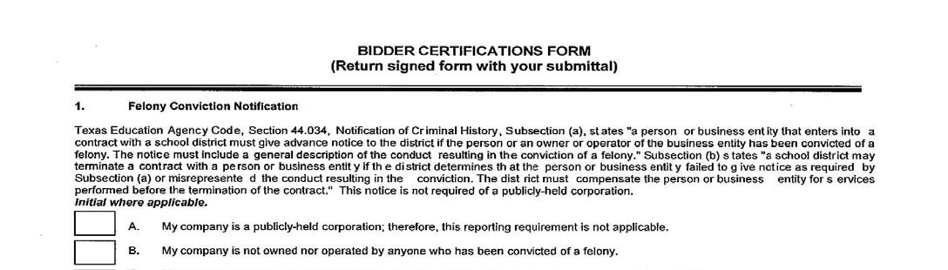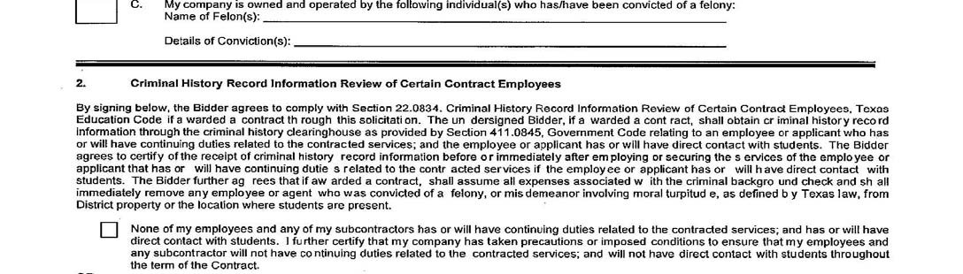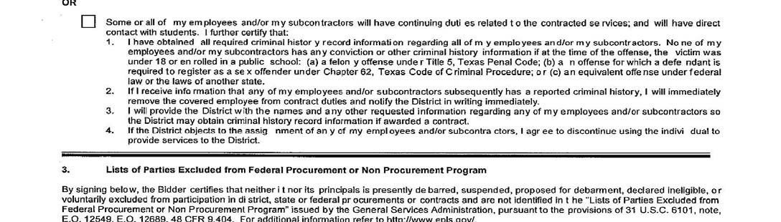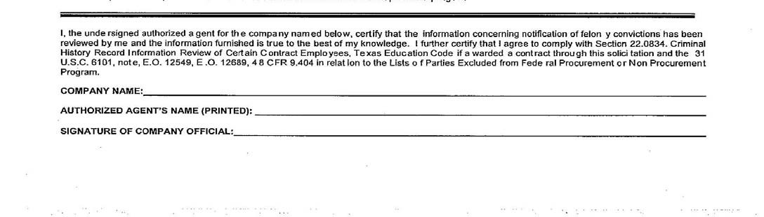

CERTIFICATION REGARDING LOBBYING PROCUREMENT

Applicable to Grants, Sub‐grants, Cooperative Agreements, and Contracts exceeding $100,000 in Federal Funds.

Submission of this certification is a prerequisite for making or entering into this transaction and is imposed by section 1352, Title 31, U.S. Code. This certification is a material representation of fact upon which reliance was placed when this transaction was made or entered into. Any person who fails to file the required certifications shall be subject to a civil penalty of not less than $10,000 and not more than $100,000 for each such failure.

The undersigned certifies, to the best of his or her knowledge and belief, that:

- No Federal appropriated funds have been paid or will be paid by or on behalf of the undersigned, to any person for influencing or attempting to influence an office or employee of any agency, a Member of Congress, or an officer or employee of Congress, an employee of a Member of Congress, or any Board Member, officer, or employee of [School] Independent School District in connection with the awarding of Federal contract, the making of a Federal grant, the making of a Federal Loan, the entering into a cooperative agreement, and the extension, continuation, renewal, amendment, or modification of a Federal contract, grant, loan, or cooperative agreement.

- If any funds other than Federal appropriated funds have been paid or will be paid to any person for influencing or attempting to influence an officer or employee of any agency, a Member of Congress, an officer or employee of Congress, an employee of a Member of Congress, or any Board Member, officer, or employee of [School] Independent School District in connection with this Federal grant or cooperative agreement, the undersigned shall complete and submit Standard Form –LLL, “Disclosure Form to Report Lobbying”, in accordance with its instructions.

- The undersigned shall require that the language of this certification be included in the awarded documents for all covered sub‐awards exceeding $100,000 in Federal funds at all appropriate tiers and that all sub‐recipients shall certify and disclose accordingly.

_________________________________________________
Name of Organization/Firm

_________________________________________________ ___________________

Signature of Authorized Representative Date

_________________________________________________
Print Name and Title of Authorized Representative

Clarification Regarding Debarment, Suspension, Ineligibility, and Voluntary Exclusion ‐ Lower Tier Covered Transactions

This certification is required by the regulations implementing Executive Order 12549, Debarment and Suspension, 7 CFR Part 3017.510, Participants’ responsibilities.

The regulations were published as Part IV of the January 30, 1989, Federal Register (pages 4722‐4733). Copies of the regulations may be contacting the Department of Agriculture agency with which this transaction originated.

- The prospective lower tier participant certifies, by submission of this proposal, that neither it nor its principals are presently debarred, suspended, proposed for debarment, declared ineligible, or voluntarily excluded from participation in this transaction by any Federal department or agency.

- Where the prospective lower tier participant is unable to certify to any of the statement in this certification, such prospective participation shall attach an explanation to this proposal.

_________________________________________________ ___________________
Name of Organization/Firm PR/Award Number or Project Name

_________________________________________________ ___________________

Signature of Authorized Representative Date

_________________________________________________
Print Name and Title of Authorized Representative

CAMPUS LOCATIONS

Site | Address | City | Zip | County
IDEA Quest | 14001 N Rooth Rd | Edinburg | 78541 | HIDALGO

